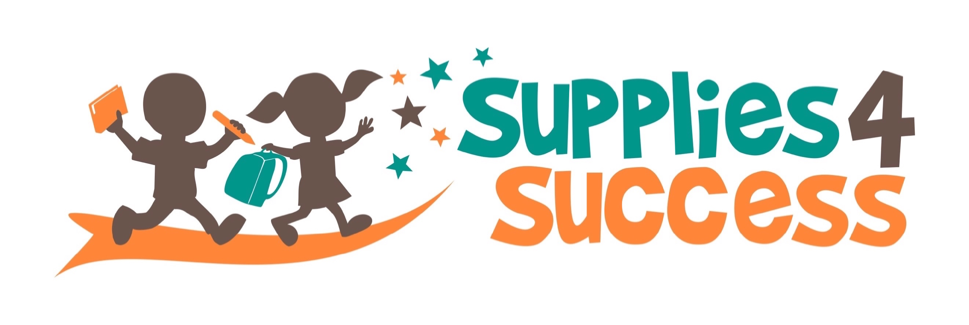
Please help make sure all children in the Glen Ellyn area
start the school year with basic school supplies!
$35
Will pay for supplies and backpack for one child

Many families in our area cannot afford to buy school supplies or winter outerwear for their children. Over the last ten years, Supplies 4 Success has provided essential schools supplies, winter outwear and gym shoes to low-income children in our two local elementary school districts: District 89 & District 41.

Thanks to contributions from caring community members, last year alone S4S provided school supply kits and backpacks to more than 800 children and winter outerwear to more than 220 students! You can help ensure all Glen Ellyn area students are able to start the school year with the supplies they need by donating today.

To Donate Online or Learn More
Visit Us at www.Supplies4Success.org
All Donations are tax deductible. Thank you!

(cut here)

Last Name: _________________________ First Name: _____________________
Email Address: __________________________________________
Street Address: __________________________________________
City: ___________________ State: _____ Zip: ______________

Yes! I will help make sure all elementary and junior high students in the Glen Ellyn area start school with the basics they need for success:

 $35 donation Provides a school supply kit and backpack for 1 student.
 $70 donation Provides school supply kits and backpacks for 2 students or winter outwear for 1 student
 $100 donation Provides school supply kit, backpack and winter outerwear for 1 student
 Other $_________ Donations of any amount are appreciated!

If your employer matches donations to K-12 charitable organizations, please list their name: ________________________________________________________

